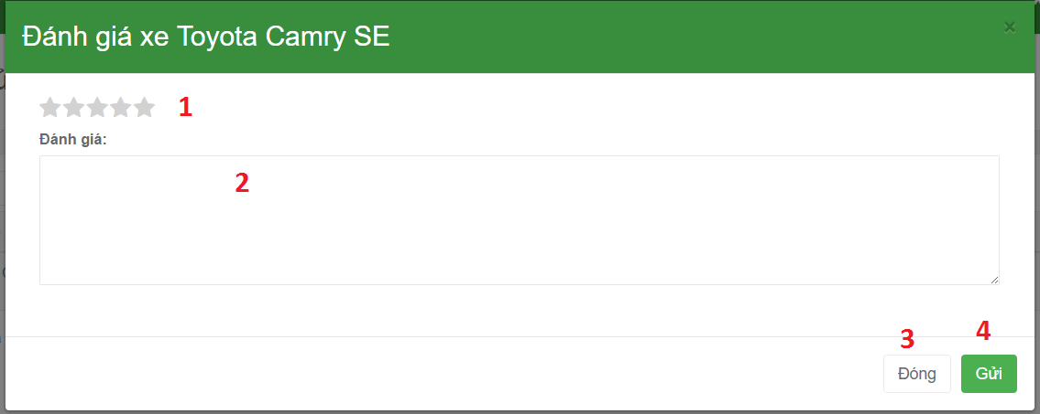

**Fields:**

|  |  |  |  |  |  |  |
| --- | --- | --- | --- | --- | --- | --- |
| No | Field Name | Description | Read Only | Mandatory | Control Type | Data Type |
| 1 | Rate for booking | Allow user rate for booking | Yes | Yes | Dropdowlist | Number |
| 2 | Comment for booking | Allow user comment for booking | Yes | Yes | Text Box | String |

**Buttons/Hyperlinks:**

|  |  |  |  |  |
| --- | --- | --- | --- | --- |
| No | Function | Description | Validation | Outcome |
| 3 | Deactivate vehicle group | Cancel and close comment pop up . | N/A | Cancel and close comment pop up. |
| 4 | Submit comment form | Send rating value and comment to server. | N/A | Send rating value and comment to server. |